**Phase I Implementation Support Proposal for:**

**Exploring Alternative Materials and Methods for Synthesizing Quantum Dots**

***In Response to ISS U.S. National Laboratory Request for a Phase I Proposal for:***

**Exploring Alternative Materials and Methods for Synthesizing Quantum Dots**

***Submission Date: 04/5/2023***

***Prepared for:***

**The ISS U.S. National Laboratory: NRLA 2023-6**

**Submitted by:**



**1500 Perimeter Parkway, Suite 215**

**Huntsville, AL 35806**

**POC: Mala Thompson**

**Telephone: 256-721-6672**

**Email: mthompson@tecmasters.com**

*This proposal includes data that shall not be disclosed outside the ISS U.S. National Laboratory or designated Principal Investigators, and shall not be duplicated, used, or disclosed – in whole or in part – for any purpose other than to evaluate this proposal as allowed in FAR 3.104. If, however, a contract is awarded to the offeror as a result of – or in connection with – the submission of this data, the ISS U.S. National Laboratory shall have the right to duplicate, use, or disclose the data to the extent provided in the resulting contract. This restriction does not limit the ISS U.S. National Laboratory’s right to use information contained in this data if it is obtained from another source without restriction. The data subject to this restriction are contained in each page of this proposal.*

# Introduction

Tec-Masters, Inc. (TMI) provides in-depth understanding of science investigations development and implementation for productive and safe operation aboard the International Space Station (ISS). TMI has developed, fabricated, integrated, verified and operated well over 100 investigation payloads and ancillary hardware items since 1995 for both the Shuttle and ISS. TMI development experience includes payloads hosted in the Microgravity Science Glovebox (MSG), Life Science Glovebox (LSG), Expedite the Processing of Experiments for Space Station (EXPRESS) racks, and Earth observation equipment on the external truss.

TMI’s technical team is led by Mr. Scott Gilley, a mechanical engineer with a graduate degree in fluid and thermal sciences with 38 years of experience. Mr. Gilley has developed several flight payloads, ancillary support equipment and flight avionics systems. He has significant experience with containment systems for safely processing molten materials at temperatures up to 1000+℃ or down to sub-zero cold stowage. He was the lead development engineer for Wetting Characteristics of Immiscibles (WCI), Particle Engulfment and Pushing (PEP), Pore Formation and Mobility Investigation (PFMI), and Solidification Using a Baffle in Sealed Ampoules (SUBSA). These experiments heated/cooled samples at controlled temperatures within + 0.1℃ stability to study solidification front behaviors. Mr. Jim McClellan is another senior team member with over 30 years of experience in electrical, avionics, control, optical imaging and recording systems. Both Mr. Gilley and Mr. McClellan are trained in on-orbit ISS operations.

# Proposed Hardware

TMI proposes that the investigation be implemented using our commercial Microgravity Research for Versatile Investigations (MaRVIn) system installed in the MSG facility. MSG is preferred since it offers double containment levels, enhanced heat dissipation capabilities, multi-channel video handling provisions and flexible remote operation support for payloads. MaRVIn has been developed and qualified for flight by TMI as a commercial facility with interchangeable experiment trays (Figure 1). TMI proposes using customized trays with configurable apparatus in each Science Tray Assembly (STA) for science processing of this investigation. There will be up to 16 thermocouple channels per STA, analog sensing and power provisions for heating and cooling functions. The Marvin Control Unit (MCU), shown on the right-hand side of Figure 1, provides remote commanding and downlinked telemetry along with science imaging from its high magnification and fluorescence tracking capable imaging system.

This approach provides automated science processing while also offering adjustability via remote commands, video recording and downlinked telemetry for the MSG configuration. The science tray items are supervised by the MCU, with both shown in Figure 1. The crew will install tailored STA(s) and initiate execution which will also enable the system for remote commanding. The MaRVIn systems maiden flight will occur aboard the NG-19 launch to the ISS. The MaRVIn data acquisition modules offer control and measurement of temperatures to typically within 0.1℃ for control setpoints along with precision ramp rates.

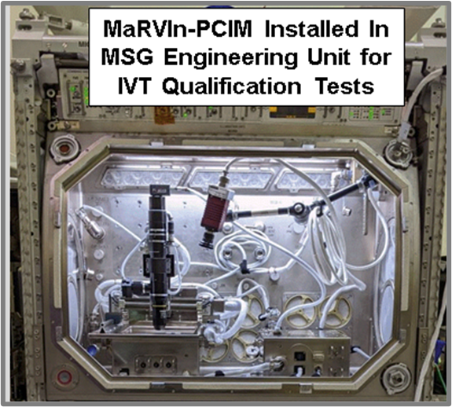Modular MaRVIn STAs will house the experiment items. Motorized syringes for positive displacement management of reaction and solvent fluids, such as for hot injection and/or electroplating solutions, will be located within exchangeable cartridges that are installed into the processing platform STA tray.

The tray’s exchangeable reactor cell cartridges can be late load cold stowed at 4°C and warmed up during installation. Thereafter, fluids will be metered through the reaction chamber’s interior at controlled injection temperatures. The chamber will have attached heating elements and cooling thermoelectric devices (TED) along with measurement and control thermocouples to maintain temperatures at specified setpoint(s) in the range of 150 to 300°C.

Figure 1: MaRVIn MSG Payload Hardware (Pictured Items are Fully Flight Qualified)

The cooling subsystem can be maintained after reaction periods to chill a specimen until relocated into ISS cold stowage. The specimens will remain there until transfer to a return vehicle’s cold stowage. This configuration will be designed to suit the experiment’s fluid volume needs, such as creating an exchangeable fluid reservoir with Luer-lok fittings if simple syringes are not sufficient.

TMI’s expertise in thermal and fluids management systems will be leveraged to successfully implement the experiment that allows for alternative methods to be processed. TMI will work with the PI team during design and development phases to optimize the processing methods and elements. The tray design will be modified from the soon-to-be flown TABOOS cartridges to support imaging from above the reactor chamber.

Controller programming of process actions will be performed pre-flight, but the MCU will allow adjustments on-orbit over the remote desktop protocol via the Joint Station LAN interfaces. The crew will ensure the tray assembly and reaction cartridges are properly positioned and mounted to the work volume interior. Science processing will then be activated and remotely run by ground operators. If a calibration run or subsequent science runs indicate adjustments are necessary, profiles can be adjusted for each run.

# Services Summary

**Development and Verification**: TMI’s secure Research and Development Laboratory and light machine shop will be used to develop and test hardware elements. Adjacent to the lab is our Tele-Science Center (TSC) with redundant workstations, video downlink capability (if utilized), and voice comms for on-orbit ops. The TSC proximity allows quick access to ground units, which can support troubleshooting off-nominal scenarios. TMI’s ventilated fume hood with a coldplate emulator like MSG’s work volume unit will be utilized for development.

**Safety Considerations:** Fluid vapor pressures, possible molten liquid control aspects, and toxicity levels will be managed. Sealed containers/tubing will be designed to accommodate volumetric fluctuations versus processing temperatures. TMI has extensive experience with safe implementation of payloads and getting them flight certified.

**Flight Operations Support**: TMI will support payload setup and operation while coordinating with ISS Mission Operations and Integration (MO&I) teams for up to 14 ops days not to exceed four weeks elapsed time. Support includes ground station setup, programming, compilation and management of science data and console support.The crew will perform setup, sample installation/exchanges, facility adjustments and hardware removal/stowage. Procedures and training materials will be created using existing templates. A crew person for approximately 2.5 hours each is needed for setup and removal with one hour needed per sample cartridge exchange.

**Post-Flight Requirements**: Processed sample(s) can be returned to Earth in cold stowage for delivery to the PI. Video streams will be compiled from operations footage recorded on-orbit. File transfers can be via cloud-based transfers or media, and post-flight sample assessment will be performed by the PI team. TMI will generate a summary report of results.

# Rough Schedule

The proposed period of performance is 15 months from ATP to develop, verify, provide manifesting inputs, and deliver hardware to the PMC site for launch integration. The on orbit start date will be determined by science priorities, host facility availability and NASA launch vehicle constraints. A detailed schedule will be created in the next phase of the contract process.

# Rough Cost Range

TMI proposes at least five ground samples for development and testing. After verifying ground performance, TMI will make two flight-like sample assemblies of each processing method for safety and qualification purposes, which may be refurbished ground units. There will be up to 15 flight sample assemblies, which supports multiple synthesis growth methods. Ground or qualification units will be refurbished for ground reference tests. The PI will provide sample materials in ready-to-load condition along with chemical and thermal properties, and an analysis of possible released chemicals in case of containment breach. This includes oxidation, decomposition, or other chemical reactions over the possible temperature range. Table 1 provides an estimate that may vary +/-25% pending further science requirements and sample definition.

Table 1. ROM Cost Estimate

|  |  |  |  |
| --- | --- | --- | --- |
| **Item** | **Ground Units** | **Qual + Flight Units** | **Total** |
| Labor | $109,439 | $133,846 | $243,285 |
| Materials | $27,010 | $45,873 | $72,883 |
| ODCs | $14,631 | $19,201 | $33,832 |
| Total: | | | $350,000 |